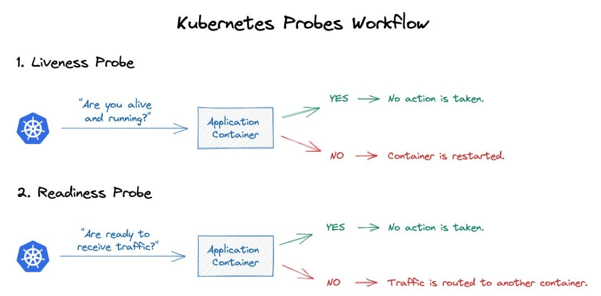

# Readiness Probe

Lab 2 — Readiness Probe

apiVersion: v1
kind: Pod
metadata:
name: readiness-pod
labels:
app: myapp

spec:
containers:
- name: nginx
image: nginx

readinessProbe:
httpGet:
path: /
port: 80

initialDelaySeconds: 10
periodSeconds: 5

# create service

apiVersion: v1
kind: Service
metadata:
name: readiness-service

spec:
selector:
app: myapp

ports:
- port: 80
targetPort: 80

kubectl apply -f readiness.yaml
kubectl apply -f service.yaml

# check ready status
kubectl get pods
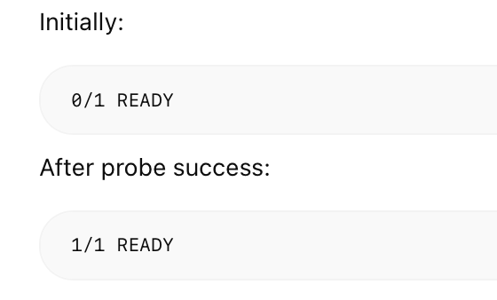

# Test Readiness Failure

